PROGRAM 1:

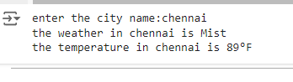

PROGRAM 2:

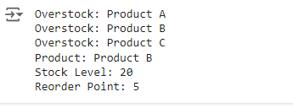

PROGRAM 4:

